Software Requirements Specification

for

Health Monitoring APP

Version 1.0

Prepared by :Heba Mostafa

4/6/20

Table of Contents

1. Introduction 2

1.1 Purpose 2

1.2 Document Conventions 3

1.3 Intended Audience and Reading Suggestions 3

1.4 Project Scope 3

1.5 References 3

2. Overall Description 3

2.1 Product Perspective 3

2.2 User Classes and Characteristics 4

2.3 Product Features 4

2.3 Operating Environment 4

2.4 Assumptions and Dependencies 5

3. External Interface Requirements 5

3.1 User Interfaces 5

3.2 Hardware interfaces 5

3.3 Communication interfaces 5

3.4 Software Interfaces 5

4. System Features 6

4.1 Authentication process 6

4.1.1 Description and priority 6

4.1.2 Stimulus/Response Sequences 6

4.1.3 Functional requirements 6

4.2 Uploading Data 6

4.2.1 Description and priority 6

4.2.2 Stimulus/Response Sequences 7

4.2.3 Functional Requirements 7

4.3 Notification system 7

4.3.1 Description and priority 7

4.3.2 Stimulus/Response Sequences 7

4.3.3 Functional requirements 7

4.4 Search engine 8

4.4.1 Description and priority 8

4.4.2 Stimulus/Response Sequences 8

4.4.3 Functional Requirements 8

4.5 Patients management 8

4.5.1 Description and priority 8

4.5.2 Stimulus/Response Sequences 8

4.5.3 Functional requirements 9

5. Other Nonfunctional Requirements 9

5.1 Performance Requirements 9

5.2 Security Requirements 9

5.3 Software Quality Attributes 9

# Introduction

## Purpose

The purpose of that document is to build an Android App for providing easy and fast connection between the patient and his doctor, so it has two faces according to the user type (patient or doctor). it allows the doctor to monitor the patient state remotely and be aware of the urgent cases. It removes the place constraints by using relational database to send the patient medical info to the doctor and collect the sensors data like the heart rate & pressure.

## Document Conventions

There's No document conventions at the moment.

## Intended Audience and Reading Suggestions

This document is intended to be used by members of the project team and by anyone who read it and want to make any improvements to the system, but he must be approved by one of the project members.

## Project Scope

Health monitoring (v1.0) App is a part of our IOT health monitoring system which will make it easier for the doctor to monitor different states of his patients Like: his heart rate, Activities…etc.

This Application is made to get more data from the patient and allow the doctor to get a report about the patient, be aware when there's an issue with him (like heart attack) and also it should call emergency numbers to let them get in at the right time, For more information about the project see our proposal.

## References

Wearable Remote Healthcare Monitoring System for Elderly.

# Overall Description

## Product Perspective

This application facilitates the process of monitoring the patient, emergency.

It will be released on only one process. The context diagram in Figure 1 illustrates the external entities and system interfaces.

The database system stores the following info:

* The users’ authentication info.
* The doctors’ comments for each patient.
* The patient sensor data & reports which contain the answers for the doctor questions form.

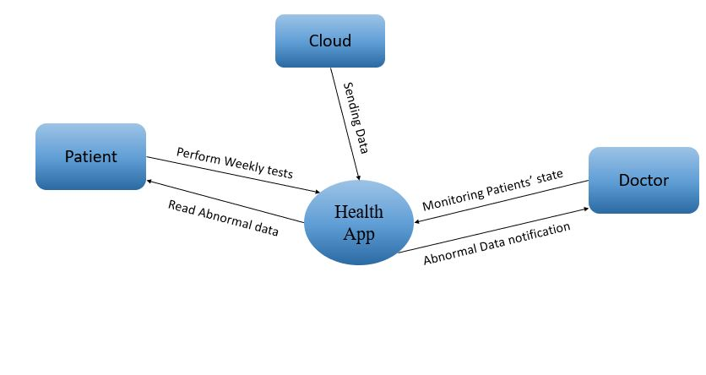

## User Classes and Characteristics

|  |  |
| --- | --- |
| Doctor | The doctor will be the main user who have some functions made for him, he can control which patients he would like to monitor, Access his patients’ reports and send his comments back to them, Search through a list of all his patients, get notifications when the data exits the normal range and get calls for critical cases, Also he is the one whom we have to make sure of his identity. |
| Patient | He is the one who the doctor wants to monitor his condition, he can fill the weekly doctor's form and get a notification when there's a new form. |

## 2.3 Product Features

FE-1:

## Operating Environment

The operating environment for our app is as listed below:

* Operating system: Any mobile phone.
* Database: Firebase database.
* Platform: Flutter.

## Assumptions and Dependencies

1. let us assume that the internet access is available for each side to send the data through the cloud.
2. Get the doctors’ identity card to confirm his job.
3. The doctor must approve the patient request to start their connection.
4. There's enough storage for the app to work.
5. Users can deal with smartphones and have an account

# External Interface Requirements

## User Interfaces

UI: => Android Application which can deal with H/W and monitor the data.

## Hardware interfaces

HI: => ESP32 => this is our microcontroller which the application should connect with when there's an abnormal reading happened.

## Communication interfaces

CI-1: => The Application should send an email to the doctor whenever the data of the patient is available.

CI-2: => The app should send a notification to the patient whenever there's a new form he should fill.

CI-3: => The app should call the doctor when there's something wrong with the patient.

## Software Interfaces

Firebase which is a Backend-as-a-Service — BaaS —so it ease the development by supporting all backend functionality and frees developers to focus crafting fantastic user experiences.

The application allows import the sensors’ data via JSON data format

# System Features

## Authentication process

### Description and priority

Users must be recognized, the patients must be attached to the doctor, and the doctor must verify his identity.

Priority: high.

### Stimulus/Response Sequences

Stimulus: Doctor sends his identity card

Response: we should recognize him, and the system will allow him to get access

Stimulus: Patient asks to enter the application.

Response: system asks for the doctor he is assigned to.

Stimulus: Patient asks to enter the application and gives the name of the doctor he communicates with.

Response: The system will search for the name given and checks whether the name exists or not, if found then it will ask the doctor to approve him.

### Functional requirements

|  |  |
| --- | --- |
| Doctor login | The system should allow the doctor to send his identity. |
| Patient login | The system should allow the patient to login after getting the doctor approvement |

## Uploading Data

### Description and priority

Each patient should be able to submit the medical form.

Priority: medium

### Stimulus/Response Sequences

Stimulus: patient gets the form and fill it.

Response: the form sent to the doctor to review it.

Stimulus: the patient gets the form and forgot to fill it.

Response: the system should send him a notification that (you must fill the form).

Stimulus: Doctor requests to see the form and the patient didn't fill it yet.

Response: System should tell the doctor that the patient didn't fill it yet.

Stimulus: Doctor asks to ignore the form this week.

Response: system will ignore the form this week.

### Functional Requirements

|  |  |
| --- | --- |
| Each patient should have a form which (he/she) will get a notification about it. | Form |
| Each patient should be able to submit the form so the doctor can see it. | Submit |
| The data in the form should be uploaded to the cloud. | Uploading |

## Notification system

### Description and priority

The system shall let the doctor to be aware of the critical situations if the sensors’ data has abnormal readings.it also works as a reminder for the patient when anew form needs to be filled.

2

### Stimulus/Response Sequences

Stimulus: there's a medical issue with the patient.

Response: system should inform the doctor and call ambulance.

### Functional requirements

|  |  |
| --- | --- |
| Notify | Users should be notified each regarding to his condition. |

## Search engine

### Description and priority

The engine should let the doctor to search for a specific patient to check his health report.

Priority: High

### Stimulus/Response Sequences

Stimulus: Doctor searches for certain patient report.

Response: the system will show the report to the doctor

Stimulus: Doctor searching for a report that doesn't exist.

Response: the system won't show the report to the doctor and asks whether he wants to restore it or not.

### Functional Requirements

|  |  |
| --- | --- |
| Search | The system should allow the doctor to search for a certain report for a certain patient to review it. |

## Patients management

### Description and priority

The doctor should be able to approve or remove patients, also he can remove some unneeded reports.

Priority: low.

### Stimulus/Response Sequences

Stimulus: when the doctor removes a patient.

Response: the system should remove the patient and all his reports.

Stimulus: when the doctor removes a report

Response: the system should remove the report and asks whether he wants to save an online copy or not.

Stimulus: when the doctor approves the patient.

Response: the patient should be added to the system.

### Functional requirements

|  |  |
| --- | --- |
| Add Patient | The system should allow the doctor to approve the addition of a certain patient |
| Remove patient | Doctor can remove the patient |
| Remove report | The doctor can remove a certain report for certain patients. |

# Other Nonfunctional Requirements

## Performance Requirements

The system has a high-performance attribute to send the data in real time to prevent any delay which may harm the patient’s health.

## Security Requirements

The system should be sure about the user identity to allow only the doctors to access his patients' info, this guarantee that the recommendations have been sent from the specialist doctor.

## Software Quality Attributes

* **RELIABILITY:** the system should be available for the users to prevent any lose in data as it deals with critical situations.
* **USABILITY:** the system is user friendly to easily satisfy a maximum number of user’s needs.
* **Recoverability:** if the internet connection is lost while uploading the data ,it will never be lost and the uploading will resume when the internet connection be available.